**Lab Task-1**

**CCCN 221 – Computer Architecture**

**Lab Instructor: Abdullah Abbasi Submission Time: As per BB**

**Student Name: Amin Yahya Selhabi Student ID: 2140632**

**Instructions:**

1. **This is a closed book and closed notes.**
2. **Copying with colleagues will be marked 0.**
3. **For answer used this text color**

**Marks:**

|  |  |  |  |
| --- | --- | --- | --- |
| Exercises | 1 | 1 | Total |
| Allocated | 1 | 1 | 2 |
| Obtained |  |  |  |
| **CLO, PLO, SO** | 3.1, V3, S05 | 3.1, V3, S05 |  |

**______________________________________________________________________________**

**Note: Student must attach the screenshot of the Final output.**

**Assemble and run the code using MIPS/QtSPIM only.**

1. **Identify and correct the errors in the following code and attach the Final output. [1 Mark]**

**A. Printing an Integer**

.data

age: .int 12 // age: .word 12

.text

li $v0, 1

lw $a0, age

syscall

**B. Printing a String**

.data

myMessage1: .asciiz "**Best of Luck**\n"

.text

li $v0, 1 // li $v0, 4

la $a0, myMessage1

syscall

1. **Write a MIPS program to add two floating point numbers, print the result and attach the Final output. [1 Mark]**

***.data***

*Num1: double 3.102*

*Num2: double 2.0*

***.text***

*(add.d $f12, $f2, $f0)*

A)

.data

age: .word 12

.text

li $v0, 1

lw $a0, age

syscall

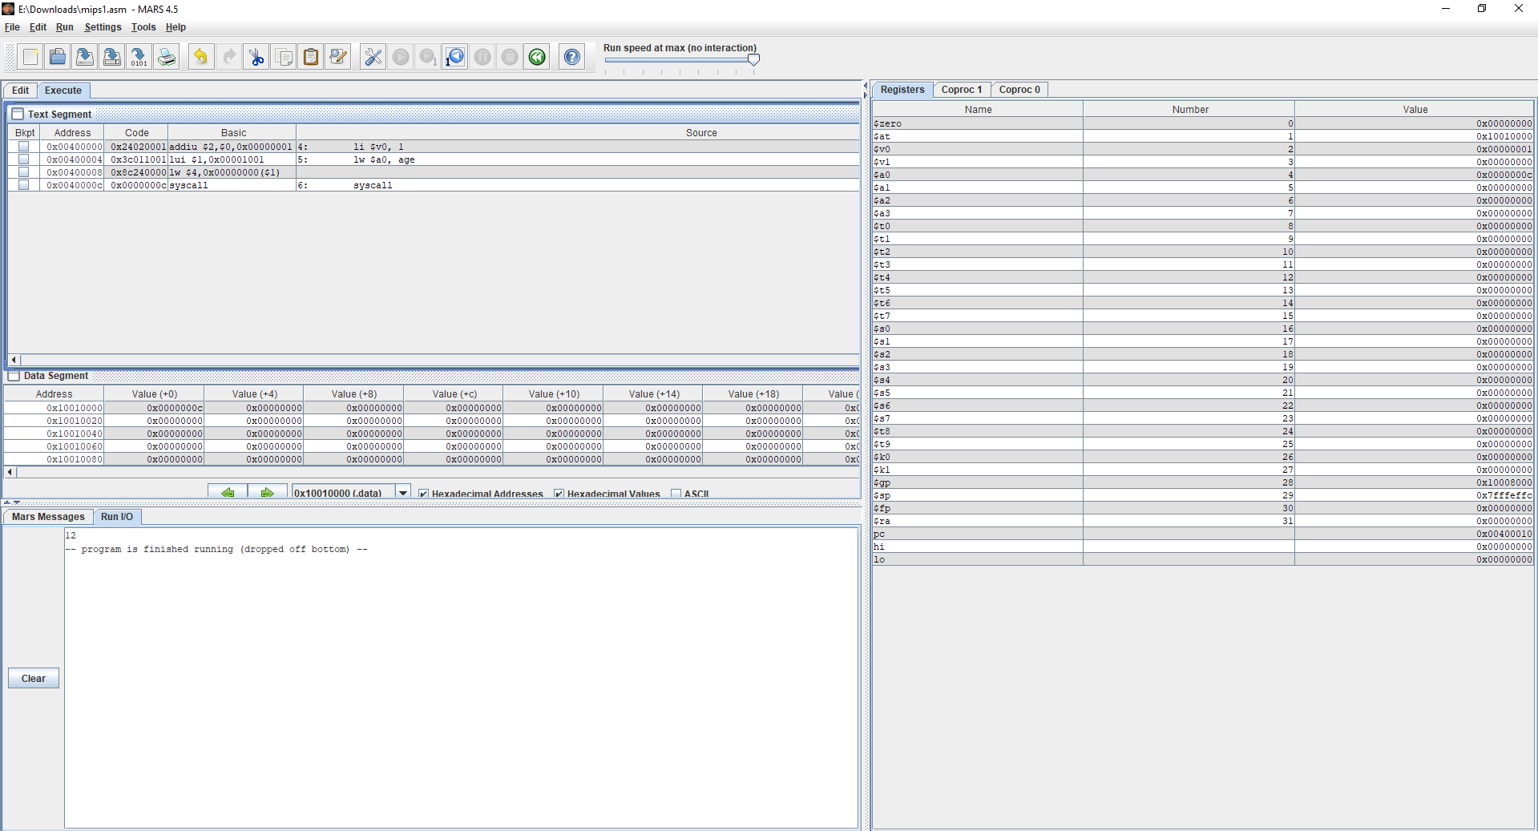

B)

.data

myMessage1: .asciiz "Best of Luck\n"

.text

li $v0, 4

la $a0, myMessage1

syscall

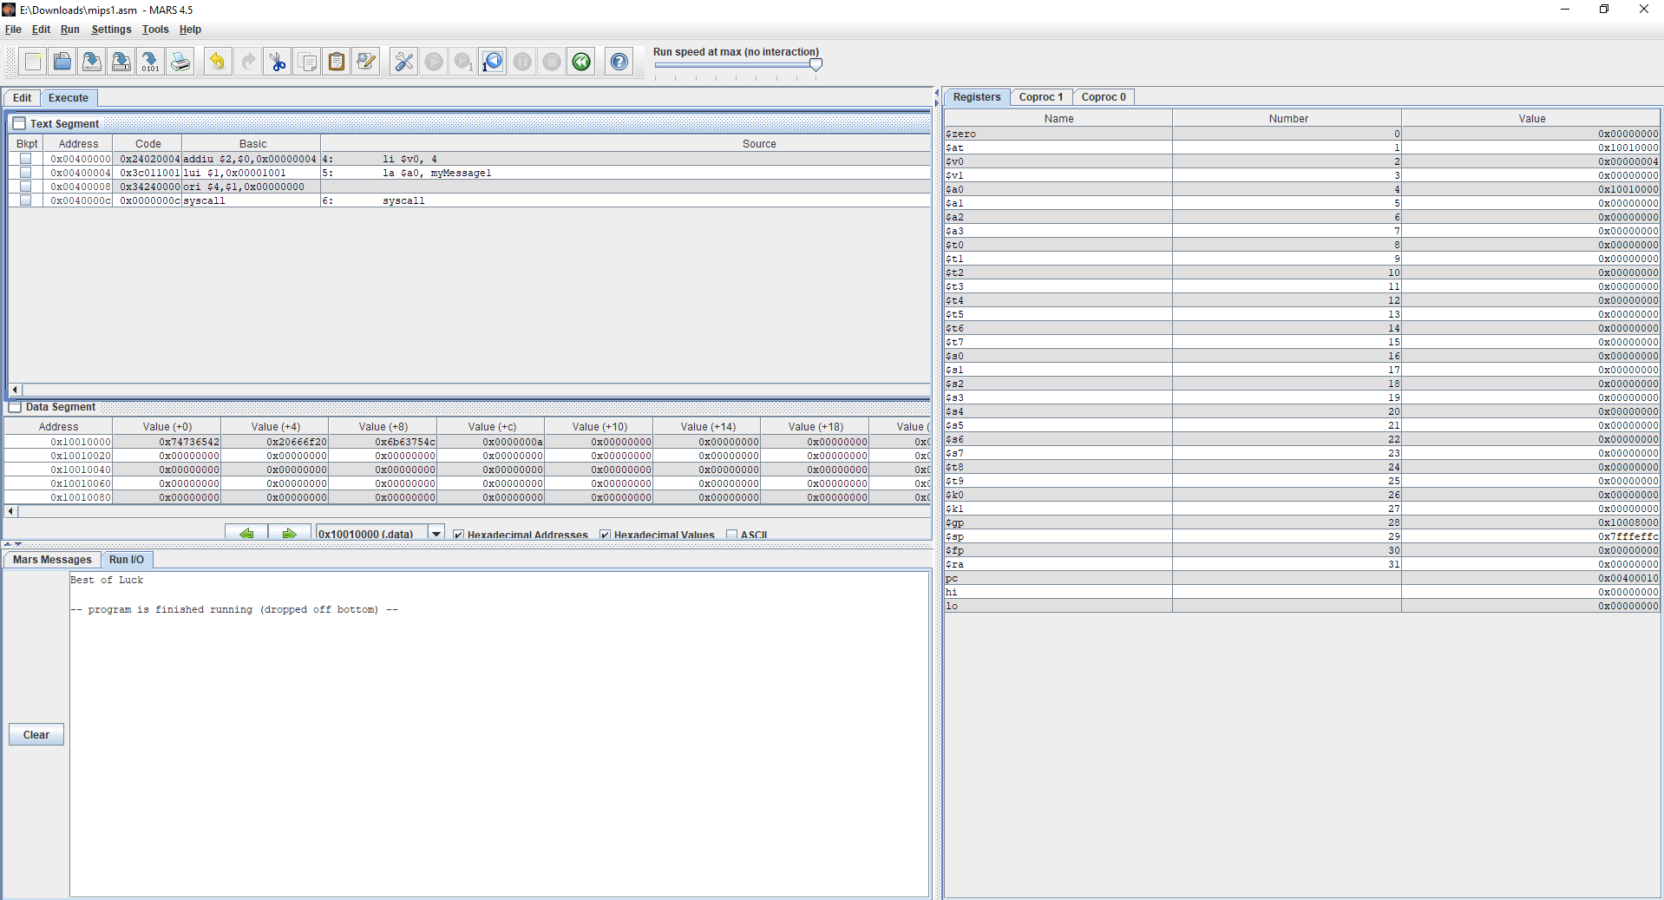

**Question 2 Answer:**

.data

Num1: .double 3.102

Num2: .double 2.0

.text

ldc1 $f2, Num1

ldc1 $f0, Num2

li $v0, 3

add.d $f12, $f2, $f0

syscall

